A Real Time and Interactive Dashboard in Tourism Industry

**Project Proposal**

By

Junyu Zhou 592115508

Yawei Li 592115518

Department of Software Engineering,

College of Arts, Media and Technology,

ChiangMai University

Project Advisor



Abstract

There are various types of data in the tourism industry with a large volume of information sources, such as text data, forming a complex and heterogeneous. However, often unreliable information.

Nowadays more decision makers need to use business intelligence and data mining, data analysis to determine company decisions. The large volume of data will be needed to process in order to make better preparation for the next tourism season.

However, one of the challenges in the tourism domain is web design and when they need to use data, they always have to gain data manually. For some users, they might need but cannot find a highly interactive website to view data directly. This is what we will do.

Our application can help them to view data in a highly interactive way (e.g. heatmap, word cloud). We will also sort customers' reviews on the website and show to the decision makers for making them do the next decision easier. They don't need to do manual statistics themselves to find data, sort data. The Real-time Interactive Dashboard for Tourism will improve user satisfaction and make their work more efficiently.

Table of Contents

1. Document History 4

2. Introduction and Background 7

3. Literature Review 8

Business Review 8

Technologies Review 15

4. Quality Standard 21

4.1 ISO 29110 for Very Small Entity (VSE) 21

4.2 Project Management Process 21

4.3 Software Implementation Process 21

4.4 Software Development Process Model 22

5. Project Plan 23

5.1 Motivation 23

5.2 Aims 23

5.3 Objectives 23

5.4 Deliverables 24

5.5 Architecture of System 25

5.6 Features 25

5.7 Mockup 27

5.8 Limitation 31

5.8 Schedule and Milestone 32

6. List of Figures 37

7. Reference 38

# 1. Document History

|  |  |  |  |  |  |
| --- | --- | --- | --- | --- | --- |
| History | Status | Date | Viewable | Editable | Responsible |
| Project Proposal_v1  Create:   * Introduction and background * Literature review * Quality standard * Project plan | Draft | 13 May, 2019 | ZJY, LYW,  AJP | ZJY, LYW | ZJY, LYW |
| Project Proposal_v2  Modify:   * Introduction and background * Literature review * Project plan   Create:   * Document history | Draft | 28 May, 2019 | ZJY, LYW, AJP | ZJY, LYW | ZJY, LYW |
| Project Proposal_v3  Modify:  - Introduction and background  - Literature review  - Project plan  - Document history  Create:  - List of figures  - Reference | Draft | 30 May, 2019 | ZJY, LYW, AJP | ZJY, LYW | ZJY, LYW |
| Project Proposal_v4  Modify:  - Introduction and background  - Literature review  - Project plan  - Document history | Draft | 3 June, 2019 | ZJY, LYW, AJP | ZJY, LYW | ZJY, LYW |
| Project Proposal_v5  Modify:  - Introduction and background  - Literature review  - Project plan  - Document history | Draft | 3 June, 2019 | ZJY, LYW, AJP | ZJY, LYW | ZJY, LYW |
| Project Proposal_v6  Modify:  - Introduction and background  - Literature review  - Project plan  - Document history  Create:  - Mockup | Draft | 18 June, 2019 | ZJY, LYW, AJP | ZJY, LYW | ZJY, LYW |
| Project Proposal_v7  Modify:  - Introduction and background  - Literature review  - Project plan  - Document history  - Mockup | Candidate | 21  June,  2019 | ZJY, LYW, AJP | ZJY, LYW | ZJY, LYW |
| Project Proposal_v8  Modify:  - Feature  review  - Project plan  - Document history  - Mockup | Final | 7  July,  2019 | ZJY, LYW, AJP | ZJY, LYW | ZJY, LYW |

ZJY = Junyu Zhou

LYW = Yawei Li

AJP = Dr. Pree Thiengburanathum

# 2. Introduction and Background

In the past decades, Thai tourism industry has experienced continuous growth and increased diversification, it has become one of the top ten tourism markets in the world. One of the reasons for their fast-economic growth is that the tourism industry has grown. Thailand's tourism industry has brought tangible economic benefits. The tourism websites played a very important role. However, when decision makers of tourism website need to make an important decision, they might face several issues:

1. A large volume of mess data affect decision

2. Irregular data might decrease working efficiently.

3. Websites that need to be a long time responded reduce user satisfaction

In those cases, decision makers will need a tool for helping them to solve problems, query report, data analysis, data mining to help enterprises make decisions. The purpose is to solve these contradictions to increase efficiency and improve their satisfaction.

Chipotle Company used to face a big issue [1]: Disparate data sources hindered teams from seeing a unified view of restaurants.

Solution: Chipotle retired their traditional BI solution for a modern, self-service BI platform. This allowed them to create a centralized view of operations so they can track restaurant operational effectiveness at a national scale.

Now their staffs can access to data more efficiently，the speed of report delivery for strategic projects has tripled from quarterly to monthly and saved thousands of hours. “This was the ticket to take all metrics and understanding to that next level,” explained Zach Sippl, Director of Business Intelligence.

Thus, it can be seen BI helped a company improve more than a little. The data visualization as a part of BI played a very important role: “Visualization is being incorporated into more and more business intelligence strategies to help drive dollars back to the bottom line by helping analysts reduce costs or drive productivity,” according to an article in Forbes.[2]

Before now, the decision maker must spend a lot of time collecting data information from their company then make decisions. For the tourism industry decision maker, huge amounts of data information not only lead them easy to make mistakes but also waste their time by doing statistics manually. However, when the concept of data visualization came, it was better when decision makers need to make some important decisions. They can easily see what the information lack is, and what points should they change with a graph, it helps to improve their efficiency and makes the work faster by using highly Interactive Data Visualization Dashboard.

A real time and interactive dashboard in tourism industry will help decision maker improve their working efficiency and reduce mistakes, but there are some limits: once designed, it can only be used on one website. If more website support is needed, we need to spend more time to design a similar application. The user provides the data to us, we convert the user's data into a visual icon, they must wait for us to design. This takes some time, so it is not flexible, and it is more suitable for a company to do quarterly statistics.

In this project, we purpose a real-time interactive dashboard for tourism industry decision maker to improve their working efficiency:

1. Automatically convert data instead of manually by hands.

2. Highly interactive data shown instead of response is shown.

3. More than a type of graph will be shown. (heatmap, work cloud, etc.)

We will Make the data sort easier and faster when decision makers will face the huge text data, reduce their working stress and it will be free for use.

# 3. Literature Review

## Business Review

1. Visit Green Land Website [2]

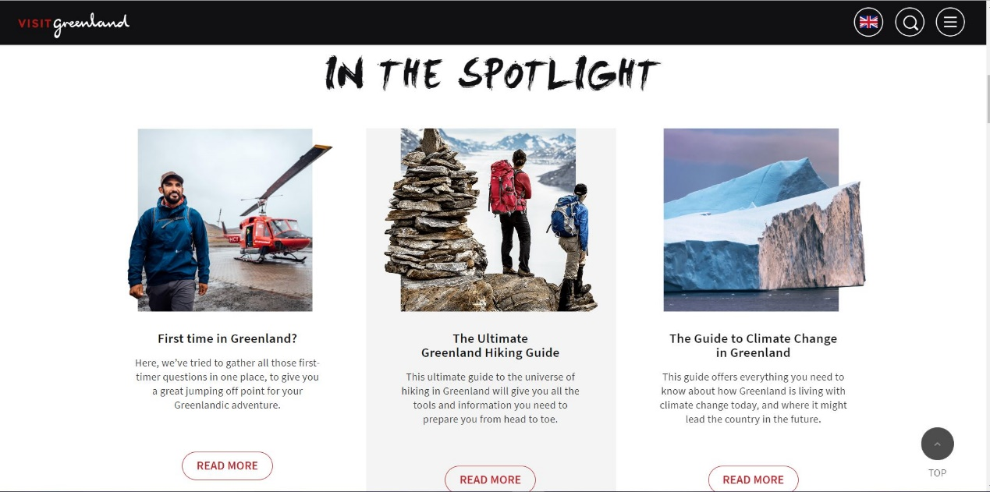

Figure 1: Visit Green Land

The Visit Green Land website is developed by KathArt. The website introduces travel information about Greenland. It is a web-based application involving the integration of HTML5/JS/CSS and Bootstrap framework. When the user clicks the button or figure in the website then it will return the related HTML file, image file and other files to the client.

-Pros

1. There is much information presented on the website.

2. The webpage is divided into serval parts base on different information.

-Cons

1. The user still needs to read a lot of words.

2. The website is not interactive so it couldn’t impress the user.

2. Tourism Tracer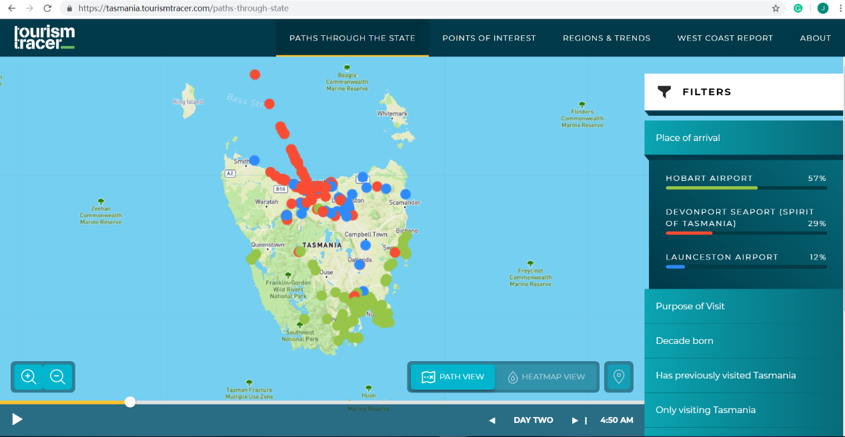[3]

Figure 2: Tourism Tracer

The Tourism Tracer website is developed by Mark Trischuk and University of Tasmania. Tourism Tracer deploys a range of flexible approaches, including tracking apps, customized hardware, survey design, recruitment ‘knowhow’, visualization tools and specialized analysis, to gain a rich understanding of visitor travel, decision-making and preferences through the combination of locational and survey data.

-Pros

1. The website builds with Ajax which is a powerful technology allows web application send and retrieve data from a server asynchronously without interfering with the display and behavior of the existing page.

2. The website has high interactivity.

-Cons

1. The user still needs much time to know how to use the website.

2. The website couldn’t contain much information.

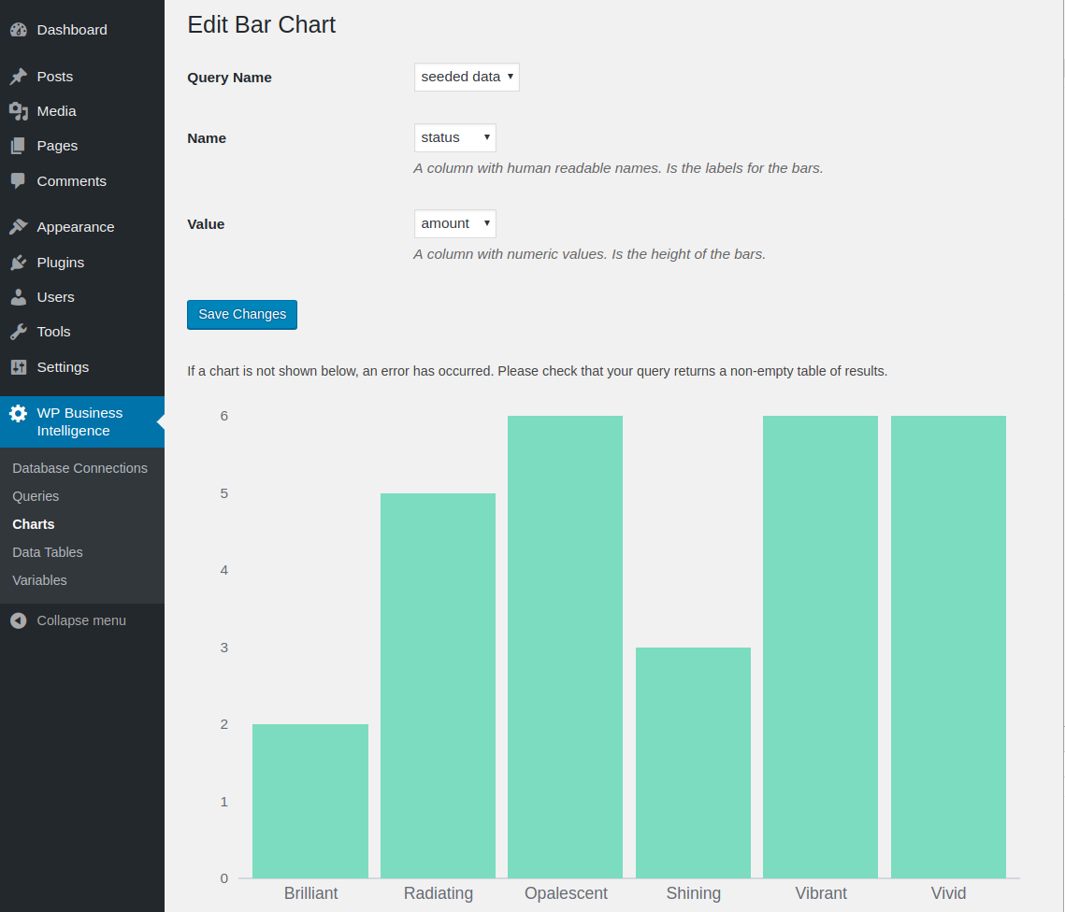3. Word Press Business Intelligence Lite [4]

Figure 3: Word Press Business Intelligence Lite

The Word Press Business Intelligence Lite website is developed by Kenton Hirowatari. It’s a plugin of Word Press. It allows user to powerfully display responsive data tables and charts on your website. This plugin is simple to use and allows you to connect with your Word Press database and display the data in real time.

-Pros

1. The user could get real time data retrieval and display features, plus chart display customization.

2. The website is easy to use.

-Cons

1. The user needs to use Word Press.

2. Report export formats are limited.

4. Chessity Teacher Dashboard [5]

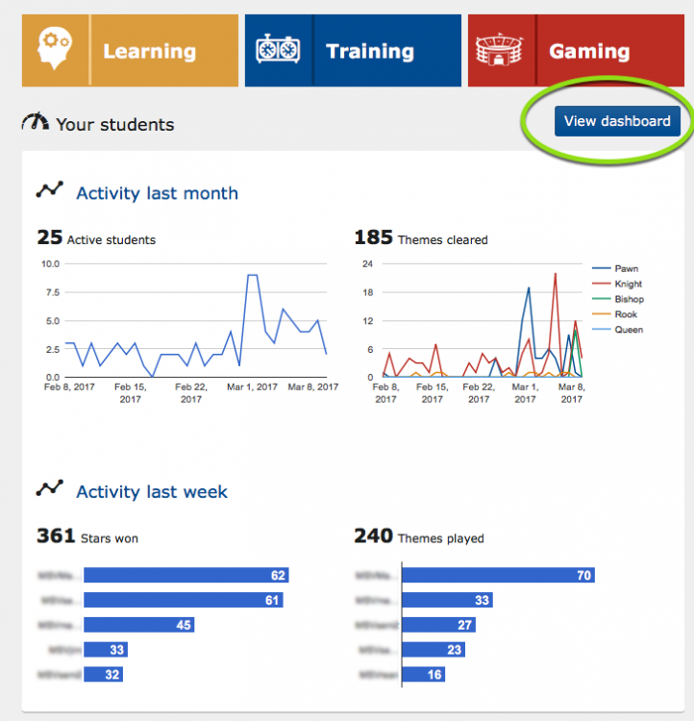

Figure 4: Chessity Teacher Dashboard

Chessity has been listed as the best ‘online chess course’ by Online Courses Review. Online Courses Review provides high-quality information for individuals seeking the best online courses and degrees. The teacher dashboard is used to seamlessly integrates with how teachers already use Chessity with their students in schools and chess clubs.

-Pros

1. The dashboard allows the teacher easily to determine a student’s progress through each level.

2. The dashboard allows Use different parameters to filter data, measure skills and motivate students-Cons

-Cons

1. The dashboard is a beta version.

2. The amount of data is limited.

## Technologies Review

1. Python



Figure 5: Python

-Python [6] is an interpreted, high-level, general-purpose programming language. Created by Guido van Rossum and first released in 1991, Python's design philosophy emphasizes code readability with its notable use of significant whitespace. Its language constructs and object-oriented approach aims to help programmers write clear, logical code for small and large-scale projects.

-Advantage of Python

Python is easy and a lot less wordy than other languages (compared to Java, which is too wordy say many programmers.). But easy and simply do not mean Python is in any way limited. There are many mathematics structures and algorithms libraries in python so that regular programmers can find them and easy to use.

2. HTML5, CSS and JavaScript



Figure 6: HTML5, CSS and JavaScript

-HTML5 [7] is a markup language used for structuring and presenting content for the World Wide Web and a core technology of the Internet.

-CSS [8] is a style sheet language used for describing the presentation of a document written in a markup language like HTML.

- JavaScript (JS) [9] is a dynamic computer programming language. It is most commonly used as part of web browsers, whose implementations allow client-side scripts to interact with the user, control the browser, communicate asynchronously, and alter the document content that is displayed. It has also become common in server-side programming, game development and the creation of desktop and mobile applications.

-Advantage of HTML5, CSS and JavaScript

HTML5 and CSS could help us to build a website that contains serval components. To build an interactive and dynamic website using JavaScript.

3. Pusher



Figure 7: Pusher

- Pusher [10] is the category leader in robust APIs for app developers building scalable real-time communication features.

-Advantage of Pusher

Pusher provides us the hosted service that makes it super-easy to add real-time data and functionality to web and mobile applications.

4. Flask



Figure 8: Flask

-Flask [11] is a Python web framework. Flask can be used for building complex, database-driven websites, starting with mostly static pages. Flask is a micro-framework for Python.

-Advantage of Flask

The reason why we use flask is the Flask framework has some libraries like Flask-PyMongo, it bridges Flask and PyMongo and provides some convenience helpers. Flask is absolute minimalism. It allows us to build a lightly database-driven website rapidly easily.

5. GitHub

**

Figure 9: GitHub

-GitHub [12] is an American web-based hosting service for version control using Git. It is mostly used for computer code. It offers all the distributed version control and source code management (SCM) functionality of Git as well as adding its own features.

-Advantage of GitHub

GitHub allows us to make better version control and code management. It makes it easy to contribute to our open source projects. It could help us track changes in our code across versions.

6. MongoDB



Figure 10: MongoDB

-MongoDB [13] is a cross-platform document-oriented database program. Classified as a NoSQL database program, MongoDB uses JSON-like documents with schema. MongoDB is developed by MongoDB Inc. and licensed under the Server-Side Public License (SSPL).

-Advantage of MongoDB

MongoDB is good at big data and performance tuning is easy compared to any relational databases.

7. React



Figure 11: React

- React [14] (also known as React.js or ReactJS) is a JavaScript library for building user interfaces. It is maintained by Facebook and a community of individual developers and companies.

-Advantage of React

The React UI is declared inside components. The UI should be composed of as many components as possible to maximize reusability. React uses one-way data flow, so only changes to the data result in changes to the UI.

8. ApexCharts



Figure 12: ApexCharts

-React-ApexCharts [15] is a wrapper component for ApexCharts ready to be integrated into our react.js application to create stunning React Charts.

-Advantage of ApexCharts

The React-ApexCharts is an officially supported library from ApexCharts, so it has better integration and stability.

# 4. Quality Standard

## 4.1 ISO 29110 for Very Small Entity (VSE)

ISO 29110[16] is a guide applies to a Very Small Entity (VSE), enterprise, organization, department or project up to 25 people, dedicated to software development. The Guide provides Project Management and Software Implementation processes which integrate practices based on the selection of ISO/IEC 12207- Systems and Software Engineering —Software Life Cycle Processes and ISO/IEC 15289 Software Engineering – Software Life Cycle Process – guidelines for the content of software life cycle process information products (documentation) standards elements.

## 4.2 Project Management Process

The purpose of the software management process is to establish and carry out in a systematic way the task of the software implementation project that allows complying with the project's objectives in the expected quality. Time and cost.

Selected process:

Project Planning Process

Project Plan Execution Process

Project Assessment and Control Process

Project Closer Process

## 4.3 Software Implementation Process

The purpose of the Software Implementation process is the systematic performance of the analysis, design, construction, integration and tests activities for new or modified software products according to the specified requirements.

Selected Process:

Software Implementation Initiation Process

Software Requirements Analysis Process

Software Architectural Design Process

Software Construction Process

Software Integration and Test Process

## 4.4 Software Development Process ModelC:\Users\42916\Desktop\Iterative Model.png

Figure 13: Iterative Model

The iterative model is an implementation of a software development life cycle that focuses on an initial, simplified implementation, which then progressively gains more complexity and a broader feature set until the final system is complete. In short, iterative development is a way of breaking down the software development of a large application into smaller pieces.

# 5. Project Plan

## 5.1 Motivation

Making the correct decision is very important for every decision maker. However, finding an effective and trustworthy application for a reasonable price is difficult due to a myriad of reasons. Our application would be useful for helping decision makers in the tourism industry make correct decisions by doing statistics data with a real-time highly interactive website. For example, the decision maker doesn’t need to refresh the page when they are editing data. It will show the changes as visualization graphs when users input different data. It will automatedly make statistics data graphs from users’ reviews and show to the decision maker. Then they could decide what should they do as the next step.

## 5.2 Aims

To create a real-time highly interactive website application for decision makers to cluster an amount of data from a tourism website as some regular graphs. According to the graphs, the decision maker could make better decisions (like what should be recommended more next season, etc.).

## 5.3 Objectives

1. Data preprocessing.

2. Data analyzing and descriptive modeling.

3. Develop the real-time highly interactive dashboard.

## 5.4 Deliverables

-Developed application

Data models

Data visualization dashboard website

-Document

Proposal

Project plan

Software requirement specification

Software design document

Testing document

Traceability record

## 5.5 Architecture of System

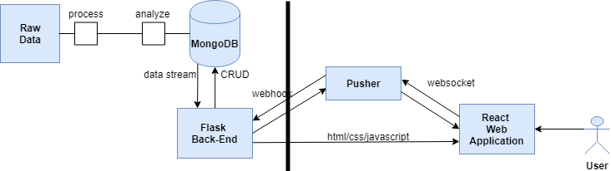

Figure 14: Architecture of System

## 5.6 Features

**Feature-1. Account authorization**

**Description:**

* Super admin could login to system.
* Super admin could view all accounts.
* Super admin could delete account.
* Super admin could add admin account.
* Super admin could accept or reject admin account register request.
* Admin could register account.
* Admin could login to dashboard.
* Admin could edit their account information.
* Admin could logout.

**Feature-2. Admin views the summary of data visualization result**

* Admin could view all visualization data summaries which contain:

1. All the summary sparkline chart.

2. Positive comments rate line chart.

3. Word frequency bar chart.

4. Number of comments bar chart.

5. Types of comments stacked column chart.

**Feature-3. View the word-cloud of data.**

Description: Decision maker could view data presented in word-cloud.

**Feature-4. View the heatmap of data.**

Description: Decision maker could view data presented in a heatmap.

**Feature-5. View the data by name, date, sentiment or search for reviews.**

Description: Decision maker could view data by select the filter or input reviews to search.

**Feature-6. All users view comments.**

Description: All the website user can view the real time comments in the first page which contains:

1. Hotel name

2. Comments

3. Rating (1-5 stars)

**Feature-7. Admin writes comments.**

Description: User could write comments.

## 5.7 Mockup

Homepage

Figure 15: Home page

Figure 16: Super admin login

Register

Figure 17: Register Page

Admin login

Figure 18: Admin login Page

Add accounts

Figure 19: Admin login Page

Figure 20: Dashboard Page

User profile page

Figure 21: User profile Page

Edit username page

Figure 22: Edit username Page

Edit password page

Figure 23: Edit password Page

## 5.8 Limitation

1. The application can only support one data source at a time. If there are other users, they will need to provide new data.

2. The decision maker cannot view the source data from the dashboard.

## 5.8 Schedule and Milestone

Figure 24: May Plan

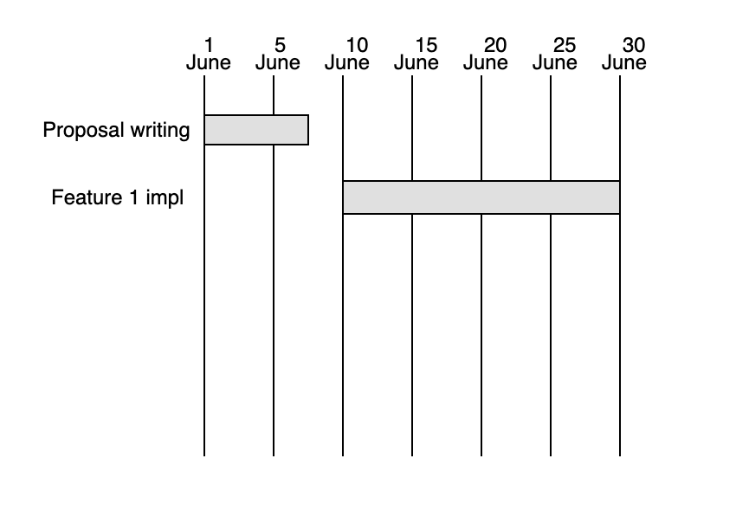

Figure 25: June Plan

Figure 26: July Plan

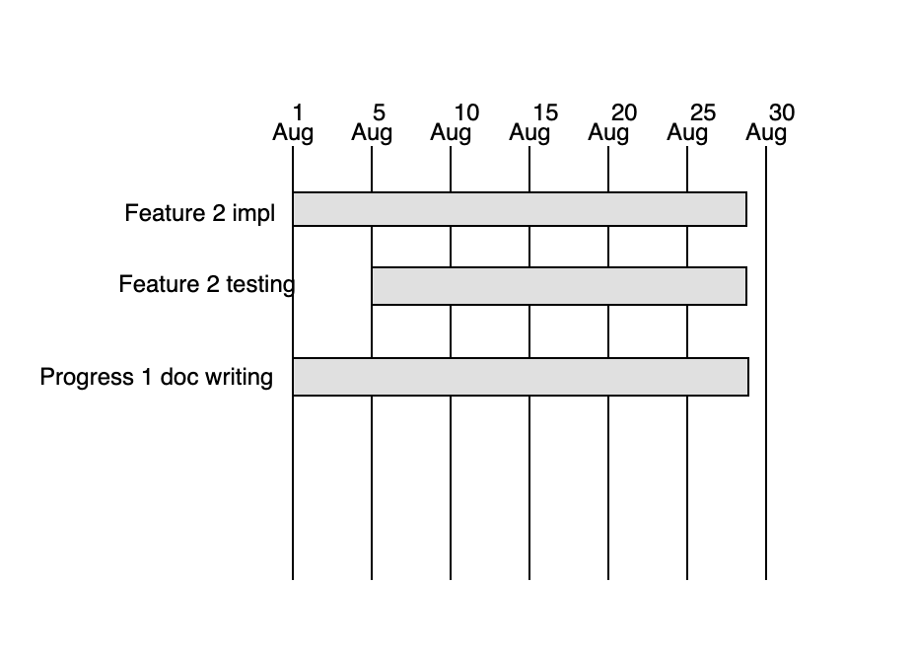

Figure 27: August Plan

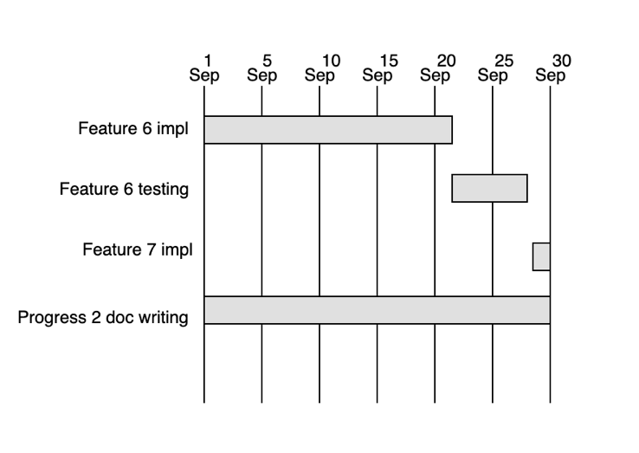

Figure 28: September Plan

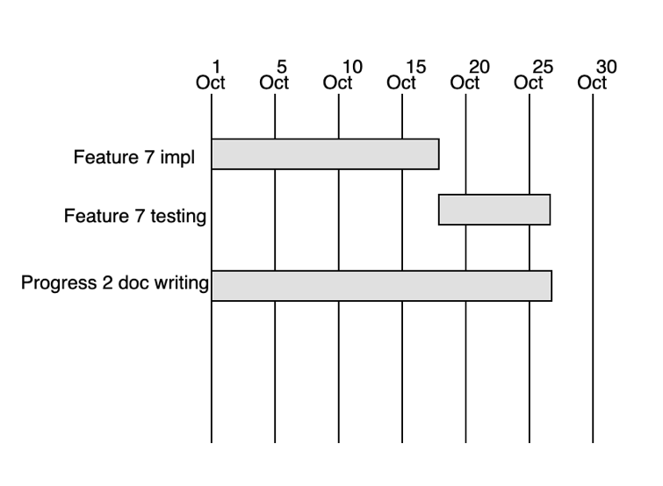

Figure 29: October Plan

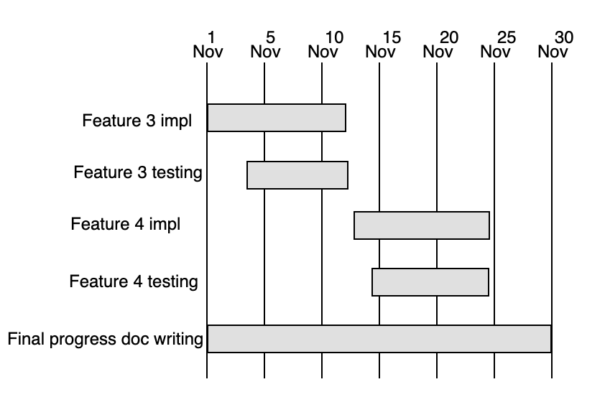

Figure 30: November Plan

Figure 31: December Plan

Figure 32: Milestone

# 6. List of Figures

Figure 1: Visit Green Land 9

Figure 2: Tourism Tracer 10

Figure 3: Word Press Business Intelligence Lite 11

Figure 4: Chessity Teacher Dashboard 12

Figure 5: Python 14

Figure 6: HTML5, CSS and JavaScript 15

Figure 7: Pusher 16

Figure 8: Flask 16

Figure 9: GitHub 17

Figure 10: MongoDB 17

Figure 11: React 18

Figure 12: ApexCharts 19

Figure 13: Iterative Model 21

Figure 14: Architecture of System 24

Figure 15: Home page 26

Figure 16: Super admin login 26

Figure 17: Register Page 27

Figure 18: Admin login Page 27

Figure 19: Admin login Page 28

Figure 20: Dashboard Page 28

Figure 21: User profile Page 29

Figure 22: Edit username Page 29

Figure 23: Edit password Page 30

Figure 24: May Plan 31

Figure 25: June Plan 31

Figure 26: July Plan 32

Figure 27: August Plan 32

Figure 28: September Plan 33

Figure 29: October Plan 33

Figure 30: November Plan 34

Figure 31: December Plan 34

Figure 32: Milestone 35

# 7. Reference

[1] Tableau Software. (2019). 5 real examples of business intelligence in action. [online] Available at: https://www.tableau.com/learn/articles/business-intelligence-examples [Accessed 3 Jun. 2019].

[2] [Visit Greenland!]. [online] Visit Greenland. Available at: https://visitgreenland.com [Accessed 2 Jun. 2019].

[3] Tasmania.tourismtracer.com. (2019). [online] Available at: https://tasmania.tourismtracer.com [Accessed 2 Jun. 2019].

[4] WordPress.org. (2019). WP Business Intelligence Lite. [online] Available at: https://wordpress.org/plugins/wp-business-intelligence-lite/ [Accessed 2 Jun. 2019].

[5] Chessity.com. (2019). New teacher dashboard now available! [online] Available at: https://www.chessity.com/en/blog/1405/New_teacher_dashboard_now_available [Accessed 2 Jun. 2019].

[6] En.wikipedia.org. (2019). Python (programming language). [online] Available at: https://en.wikipedia.org/wiki/Python_(programming_language) [Accessed 2 Jun. 2019].

[7] En.wikipedia.org. (2019). HTML5. [online] Available at: https://en.wikipedia.org/wiki/HTML5 [Accessed 2 Jun. 2019].

[8] En.wikipedia.org. (2019). Cascading Style Sheets. [online] Available at: https://en.wikipedia.org/wiki/Cascading_Style_Sheets [Accessed 2 Jun. 2019].

[9] En.wikipedia.org. (2019). JavaScript. [online] Available at: https://en.wikipedia.org/wiki/JavaScript [Accessed 2 Jun. 2019].

[10] Pusher. (2019). Pusher | Leader In Realtime Technologies. [online] Available at: https://pusher.com/ [Accessed 2 Jun. 2019].

[11] En.wikipedia.org. (2019). Flask (web framework). [online] Available at: https://en.wikipedia.org/wiki/Flask_(web_framework) [Accessed 2 Jun. 2019].

[12] En.wikipedia.org. (2019). GitHub. [online] Available at: https://en.wikipedia.org/wiki/GitHub [Accessed 2 Jun. 2019].

[13] En.wikipedia.org. (2019). MongoDB. [online] Available at: https://en.wikipedia.org/wiki/MongoDB [Accessed 4 Jun. 2019].

[14] En.wikipedia.org. (2019). React (JavaScript library). [online] Available at: https://en.wikipedia.org/wiki/React_(JavaScript_library) [Accessed 4 Jun. 2019].